**Developing the emotional intelligence of a successful change leader**

We all know that in general those people who find themselves managing change projects are bright. They have proved this by the fact that they have progressed in their careers and most probably passed exams to gain the required qualifications. However, we also know that managing and leading change, whilst at times a technical process, is also highly social and interactive. The change manager/leader needs to be able to work productively with other people and to manage relationships in ways that build engagement and generate collaboration and trust. This requires an ability to develop not only one’s intellectual IQ also one’s emotional EQ.

Emotional intelligence has been defined by Peter Salovey and John Mayer (2008) as, “the ability to monitor one’s own and other people’s emotions, to discriminate between different emotions and label them appropriately, and to use emotional information to guide thinking and behaviour.” The global thought leader on the subject, Daniel Goleman defines emotional competence as, “a learned capability based on emotional intelligence that results in outstanding performance at work” (Goleman, 1998b).

Researchers such as Huy, (1999) have studied the impact that change leaders’ high or low emotional intelligence has on the success outcomes of change projects. They argue that employers should develop their managers’ capability to respond to emotions when attempting to facilitate organisational change, as change leaders who consciously develop their EQ will be able to manage emotional encounters in mature, reflective, and intelligent ways that benefits the change process. Goleman argues that EQ can be developed and improved. However, for this improvement to happen, the change manager/leader needs a framework to work with while travelling this deeply personal and introspective, personal development journey. Daniel Goleman has developed such a framework of emotional competencies that the change leader can work with.

The framework differentiates between ‘Personal Competence’ and ‘Social Competence’. The former involves self-awareness and self-management of our emotional and behavioural states. The latter involves a broader sense of awareness of the relational social field and our efforts and results at relationship management. One could categorise these two dimensions as ‘Intra’ and ‘Inter’ personal skills. Self-awareness and Self-Regulation as intrapersonal skills involve the capacity for self-reflecting on the nature of our emotional and behavioural states that we generate during social interactions as part of the unfolding change project. For example, if I tune into my capability for self-awareness, or mindfulness regards my internal states I can ‘notice’ the emotional state of anxiety that is flooding through me. I can also feel my body’s physical reaction as I tense up and contract. I can ask myself the following questions and generate probable answers as detailed below:

‘How am I feeling just now?

“Uptight and anxious”

“How is my body responding to these emotions?”

“I am contracting and tensing - moving towards defensive body language”

“How do I feel about feeling that way?”

“Not very happy.”

“What is it about the meeting that you are focusing on that is making you unhappy?”

“I am concerned about some of the participants who are quite aggressive and very critical of the change process.”

“What else could you focus on going into this meeting that would be more resourceful for you and for everyone else?”

“I could focus on the opportunity to engage with everyone, to share my enthusiasm and optimism and update on the achievements we have made and look forward to receiving feedback, regardless of how challenging, as I know everyone is coming from a positive place from their perspectives.”

“So that is what you are going to do…. excellent…. how does the idea of applying that strategy make you feel now?”

“Calmer, more certain and confident …. quite relaxed.”

The above technique is a self-coaching method that can be used to practice self-reflection and thus improve upon one’s emotional intelligence competencies. It is a reframing method which will break the pattern of experiencing repetitive behaviours and emotions that are not proving resourceful for you. We can look at this sense making process through the model below.

Model 1 Wheel of Repetitive Emotional and Behavioural States (Maio & Haddock, 2010)

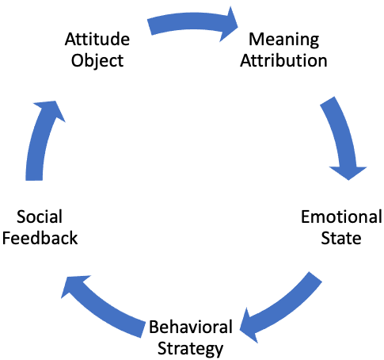

This model shows how we initially identify an attitude object which is any perception of reality we construct in relation to a stimulus. For example, if a manager talks over a team member at a meeting with what the team member regards as a dismissive tone of voice, they would allocate a meaning against this attitude object, e.g. ‘the manager does not respect me and has insulted me in front of my peers’ and this meaning construction subsequently becomes their frame of reference regards the attitude object; it becomes our map of reality which we imbed within our unconscious mind as a memory.

**Key Lessons**

The meaning we attribute towards the attitude object generates an emotional response which we can refer to as our ‘emotional state’. The type of emotional response and its strength depends on the value we place on the attitude object and the meaning we attribute to it. Our emotions do matter and how we manage these as change leaders will have a significant influence on how successful we may be.

**Self-learning Exercise**

Identify a time when you were to chair a meeting or deliver a presentation, or even attend an interview when you were not, on reflection, in a resourceful state. You may have felt that you were a bit stressed or anxious or some other kind of emotional state that got in the way of you being at your very best for the event. Using the technique above, meta reflect on the event of your choice and reframe aspects of the content that may be stimulating negative thoughts and energy. Then reflect on how this method may help you in your career as a change manager/leader. Use the following method to guide your reframing process:

1. What was the nature of the activating event that triggered your emotional response and how would you describe your feelings?
2. What were the core beliefs you associated with the activating event that triggered your emotional responses?
3. What were the consequences of you adopting the emotional response you chose?
4. If you were to reframe the beliefs you associated with the activating event i.e. dispute these, how could you reframe these?
5. How does this reframing of the original beliefs influence or change the energy you feel emotionally towards the activating event?